Property of Time-Invariance (Shift-Invariance) for a System Under Observation
Prof. Brian L. Evans and Mr. Jaehong Moon
The University of Texas at Austin, bevans@ece.utexas.edu
September 20, 2018 and updated January 2, 2023, and January 23, 2023
When evaluating system properties, we treat a system as a closed box and analyze the relationships between input signals and their corresponding output signals. This process assumes that after inputting a signal, we can return the system to its original state.
A continuous-time system with input signal $x\left(t\right)$ and output signal $y\left(t\right)$ is time-invariant (shift-invariant) if whenever the input signal is delayed by $t_{0}$ seconds, then the output signal will always be delayed by $t_{0}$seconds as well for all real values of $t_{0}.$
A way to visualize the time-invariance property is to show the equivalence between
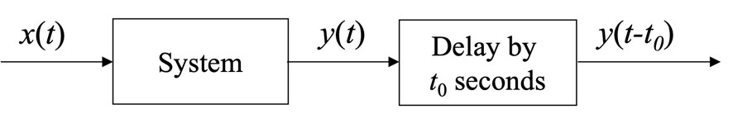
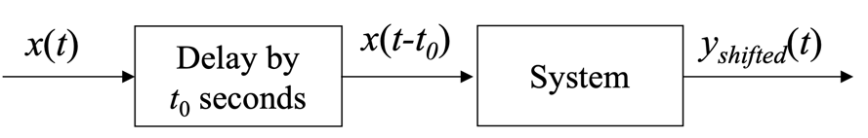
That is, does $y_{shifted}\left(t\right)=y\left(t-t_{0}\right)$ for all possible real constant values of $t_{0}$?
One-sided infinite observation. Let’s consider the system under observation for $t≥0^{-}$. Time $0^{-}$ means a time of 0 seconds before occurrence of a Dirac delta occurring at the origin. We can only observe $x\left(t\right)$ for $t≥0^{-}$ and $y\left(t\right)$ for $t≥0^{-}$. This means that we can only observe $x\left(t-t_{0}\right)$ for $t≥t_{0}$ and $y\left(t-t_{0}\right)$ for $t≥t_{0}$.
Example. Consider a delay system that delays the input by T seconds, and we can only observe the input signal and the output signal for $t≥0^{-}$.
Conceptually, the delay block can be thought as a long wire that conducts electricity from the input to the output. Assuming electrons travel at 2/3 the speed of light, the length of the wire would be (2/3) c T where c is the speed of light (3 x 10⁸ m/s). Such an implementation would be impractical, but nonetheless helpful in analyzing the system.
The first observed output value $y\left(0\right)$ would be due to the initial conditions in the delay system. In fact, the first T seconds of the output would due solely to the initial conditions in the system. For input $x\left(t\right)$ and output $y\left(t\right),$once the initial conditions have been output, $y\left(T\right)=x(0)$. That is, it takes T seconds for an input value (voltage) to arrive at the output.
The initial conditions for the delay system consist of the voltage values at different points in the wire at t = 0. Let’s denote these voltage values v(t) for –T < t ≤ 0. That is, $v\left(0\right)$ will be first, and $v\left(-T\right)$ will be the last, value among the initial conditions to be output. The spatial location for the voltage v(t) for –T < t ≤ 0 is (-2/3) c t meters from the output location.
Let x(t) = 0 for 0 ≤ t < T and 1 for t ≥ T. For input x(t), the output is
$$y\left(t\right)=\left[\begin{matrix}v\left(-t\right) & for 0 ≤ t < T \\ x\left(t–T\right) & for t ≥ T\end{matrix}=\right.\left[\begin{matrix}v\left(-t\right) & for 0≤t<T \\ 0 & for T≤ t<2T \\ 1 & for t≥2T\end{matrix}\right.$$
Let’s keep the same initial conditions, i.e. v(t) for –T < t ≤ 0, and the same definition for signal x(t). Now, we input $x(t-t_{0})$ into the delay system
$$x\left(t-t_{0}\right)=\left[\begin{matrix}unobserved & for 0 ≤ t < t_{0} \\ 0 & for t_{0} ≤ t < T+t_{0} \\ 1 & for t ≥ T+t_{0}\end{matrix}\right.$$
and the output is
$$y_{shifted}\left(t\right)=\left[\begin{matrix}\begin{matrix}v\left(-t\right) \\ unobserved\end{matrix} & \begin{matrix}for 0 ≤ t < T \\ for T≤ t < T+t_{0}\end{matrix} \\ \begin{matrix}0 \\ 1\end{matrix} & \begin{matrix}for T+t_{0}≤ t<2T+t_{0} \\ for t ≥2 T+t_{0}\end{matrix}\end{matrix}\right.=\left[\begin{matrix}v\left(-t\right) & for 0 ≤ t < T \\ unobserved & for T≤ t < T+t_{0} \\ y\left(t-t_{0}\right) & for t ≥T+t_{0}\end{matrix}\right.$$
$y_{shifted}\left(t\right)$ only equals $y\left(t-t_{0}\right)$ for $t≥ T+t_{0}$ because the initial conditions did not shift in time even though the input did.
Plots of the signals are given next followed by an analysis of initial conditions:
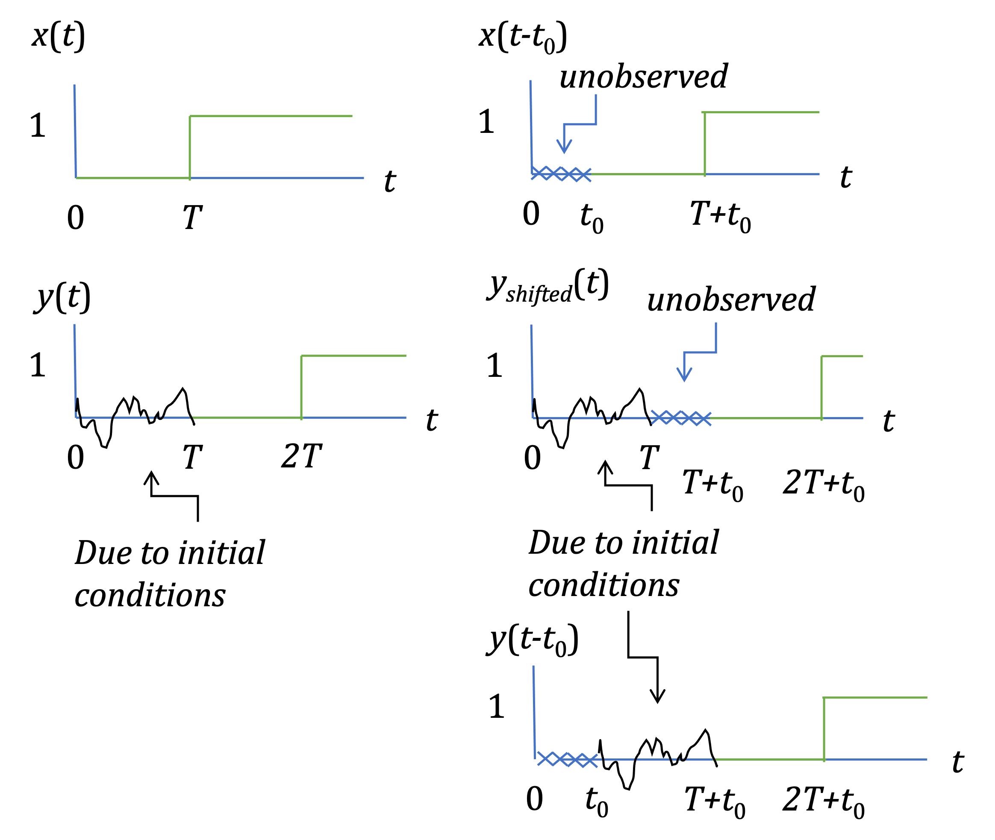If the system were time-invariant, then $y_{shift}\left(t\right)=y\left(t-t_{0}\right)$ for all real $t_{0}$ and $t≥0^{-}$. This holds for $for t ≥T+t_{0}$. For $0 ≤ t < T+t_{0}$, all unobserved values and initial conditions would have to be equal to a constant value.

